Multivariate Testing Outputs

**Platinum Free Interval** (This is negative if the patient had received treatment after the date of progression or recurrence or if the date of the last platinum treatment is after the date of last followup)

Significant

* ProgorRecur (progression or recurrence)

|  |  |
| --- | --- |
| ProgorRecur Counts | |
| NO | YES |
| 16 | 117 |

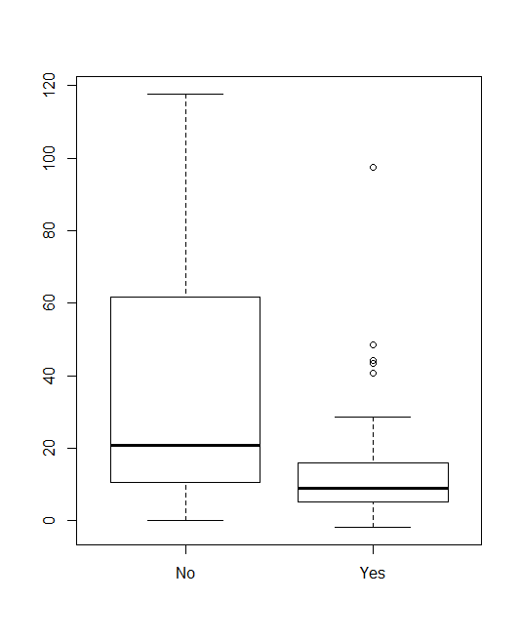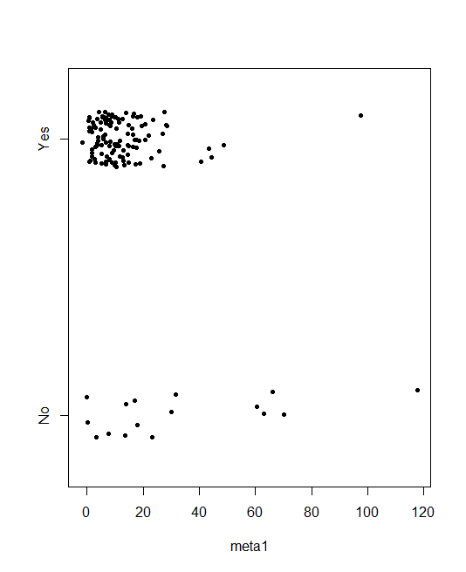

* Vital_status (vital status)

|  |  |
| --- | --- |
| Vital Status Counts | |
| LIVING | DECEASED |
| 85 | 48 |

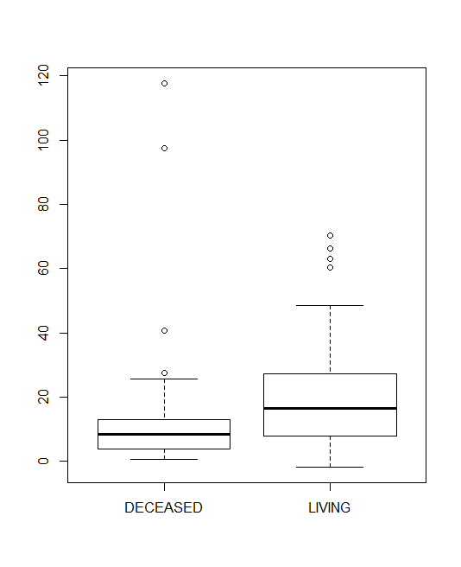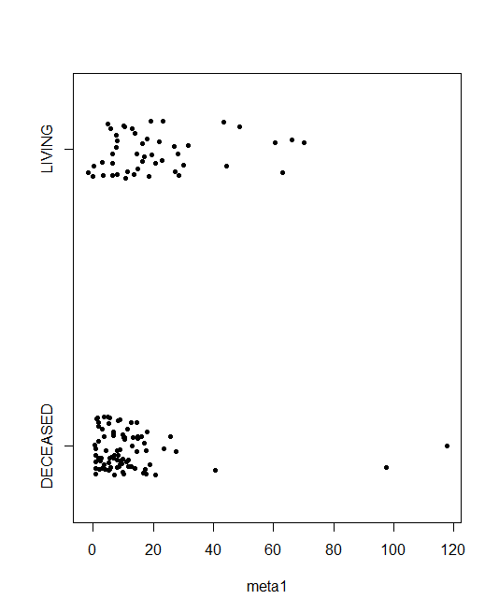

Not Significant

* Residual_tumor (residual tumor) (changed from R1/R0/[Not Applicable] to residual/[Not Applicable]
  + Wilcoxon rank sum test: p = .2698

|  |  |
| --- | --- |
| Residual Tumor Counts | |
| [NOT APPLICABLE] | RESIDUAL |
| 119 | 14 |

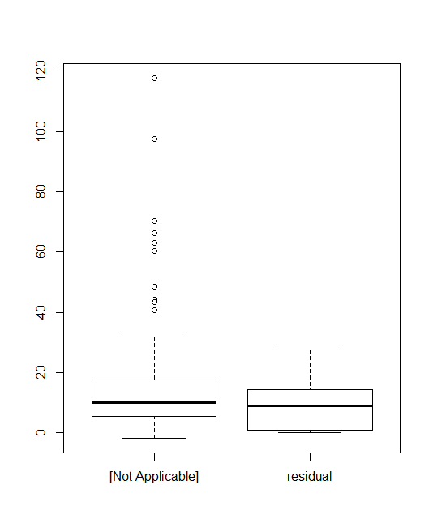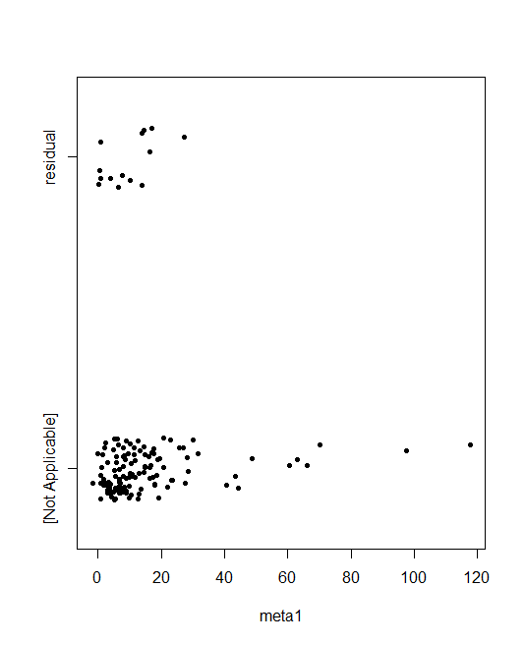

**Platinum Status** (It describes whether the patient was resistant to platinum (chemotherapy) treatment)

|  |  |  |  |
| --- | --- | --- | --- |
| Platinum Status Counts | | | |
| Missing | Resistant | Sensitive | Tooearly |
| 41 | 35 | 95 | 3 |

Significant

* ProgorRecur (progression or recurrence)

|  |  |
| --- | --- |
| Progression or Recurrence Counts | |
| NO | YES |
| 16 | 117 |

|  |  |  |  |
| --- | --- | --- | --- |
| Platinum Status v Progression or Recurrence | | | |
|  | NO | UNKNOWN | YES |
| MISSING | 3 | 10 | 28 |
| RESISTANT | 0 | 0 | 35 |
| SENSITIVE | 13 | 0 | 82 |
| TOO EARLY | 3 | 0 | 0 |

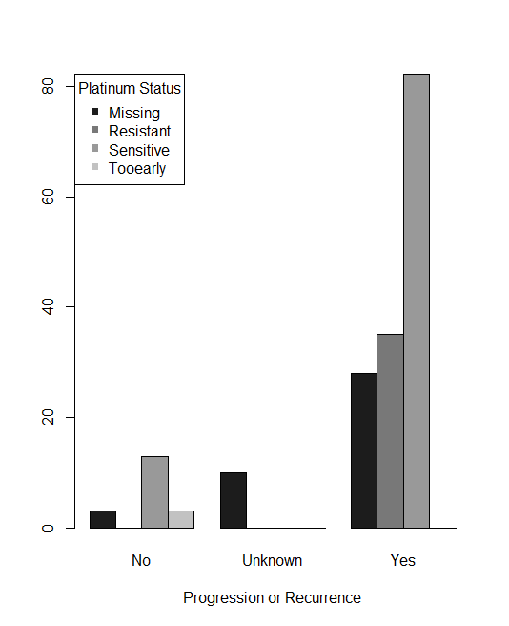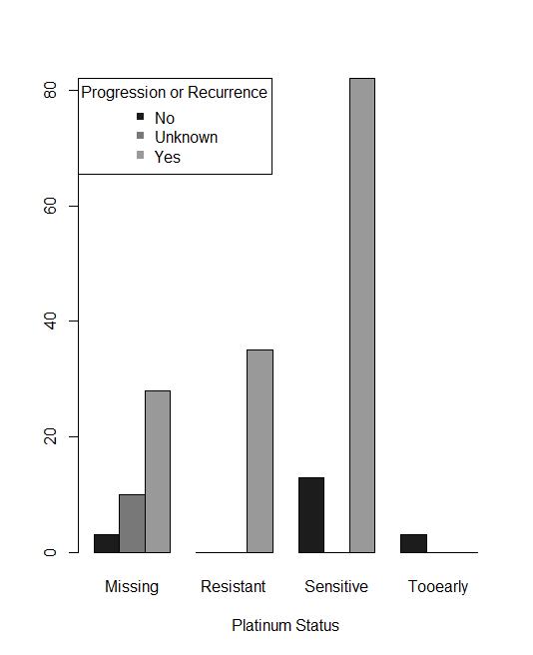

* Primary_therapy_outcome_success (it means the primary treatment a success (the patient survived))

|  |  |  |  |
| --- | --- | --- | --- |
| Primary Therapy Outcome Success Counts | | | |
| Complete Response | Partial Response | Progressive Disease | Stable Disease |
| 105 | 24 | 12 | 9 |

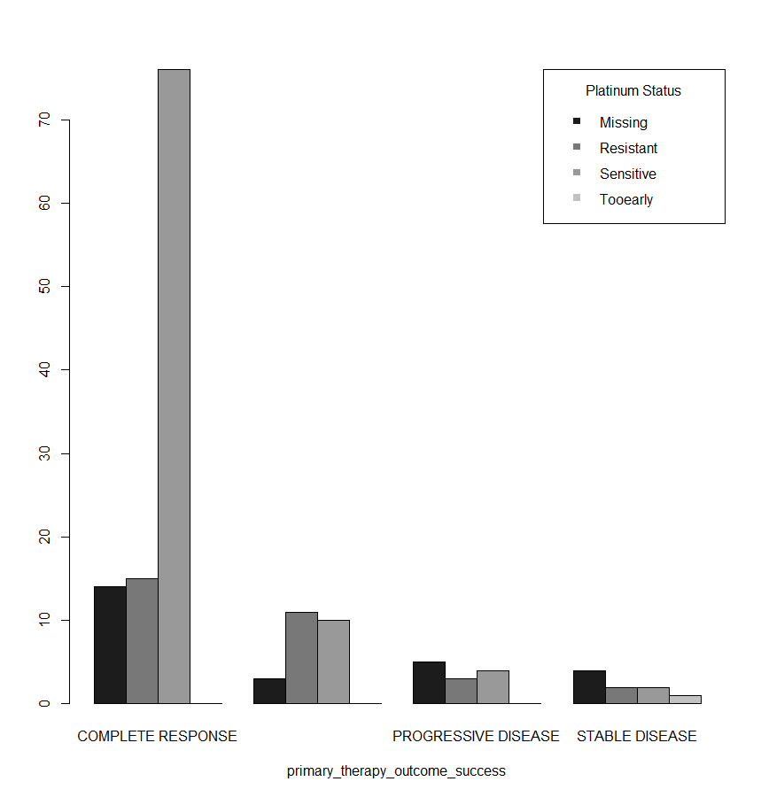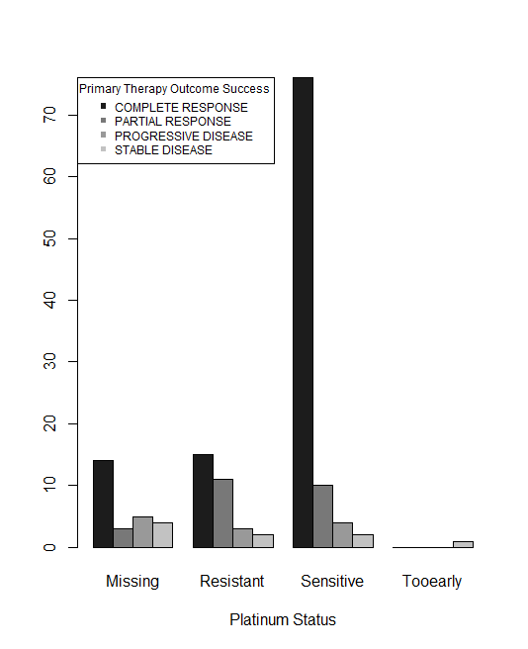

Not Significant

* Additional Therapy Type (not chemo) (drug, immuno, pharmaceutical, radiation)

|  |  |
| --- | --- |
| Additional Drug Therapy Counts | |
| NO | YES |
| 152 | 13 |

|  |  |
| --- | --- |
| Additional Immuno Therapy Counts | |
| NO | YES |
| 164 | 2 |

|  |  |
| --- | --- |
| Additional Pharmaceutical Therapy Counts | |
| NO | YES |
| 153 | 13 |

|  |  |
| --- | --- |
| Additional Radiation Therapy Counts | |
| NO | YES |
| 156 | 10 |

